Project Design Phase-II
Data Flow Diagram & User Stories

Date | 28 October 2026
Team ID | Ujjawal Rathod (Individual Capstone)
Project Name | Electric Vehicle Market Performance & Insights
Maximum Marks | 4 Marks

Data Flow Diagrams:
A Data Flow Diagram (DFD) is a traditional visual representation of the information flows within a system. A neat and clear DFD can depict the right amount of the system requirement graphically. It shows how data enters and leaves the system, what changes the information, and where data is stored.
DFD Symbol Legend
Symbol | Name | Description
Oval / Rounded  shape | External Entity | A person, organization, or system outside the project that sends or receives data (e.g., Customer, Payment Gateway).
Rectangle with  numbered header | Process | An activity that transforms incoming data into outgoing data (e.g., Validate Request, Process Order).
Rectangle (solid fill, no number) | Data Store | A place where data is held for later use (e.g., Customer Database, Inventory).
Labeled arrow | Data Flow | The movement of data between entities, processes, and data stores, labeled with what data is being passed.

Example: DFD Level 0 (Industry Standard)



Project Data Flow Diagram (EV Market Tableau & Flask BI Architecture):
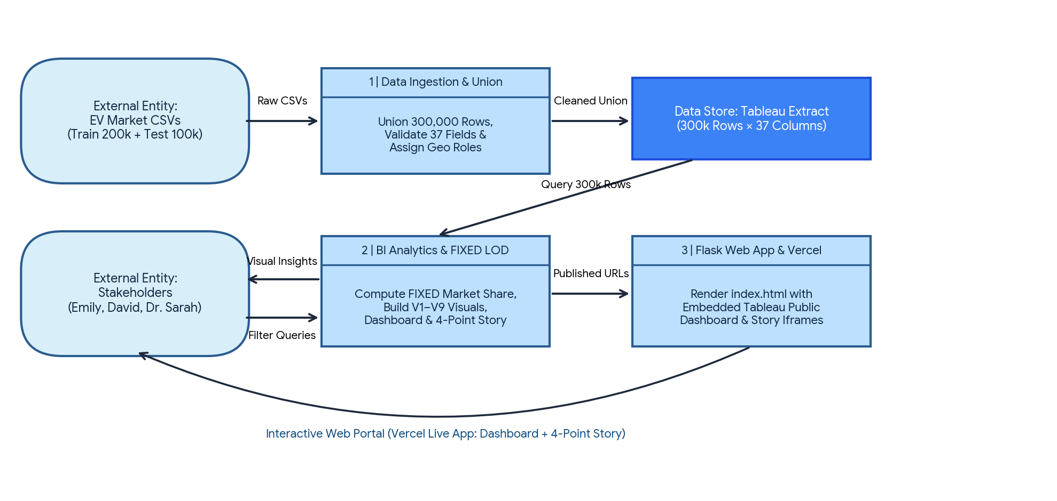
User Stories
Use the below template to list all the user stories for the product.
User Type | Functional Requirement (Epic) | User Story Number | User Story / Task | Acceptance criteria | Priority | Release
Emily Johnson  (Market Strategy Director) | Category Sales & Volume Analysis | USN-1 | As a Market Strategy Director, I want to view total annual sales across all 15 EV vehicle categories sorted descending (V1) so that I can identify which segments drive the highest volume. | Horizontal bar chart (V1) displays Two-Wheeler Scooter leading, followed by Sedan, Hatchback, and Compact SUV. | High | Sprint-1
Emily Johnson  (Market Strategy Director) | Historical Trend Analysis | USN-2 | As a Market Strategy Director, I want to track annual sales trends from 2018 to 2026 for the Top 5 categories (V3) so that I can evaluate whether segments are growing or stabilizing. | Multi-line chart (V3) displays discrete model years 2018–2026 for the top 5 categories with clean मिलियन (M) axis formatting. | High | Sprint-1
David Chen  (Automotive BI Manager) | Competitor Market Share (FIXED LOD) | USN-3 | As an Automotive BI Manager, I want to see the Top 10 manufacturers with their true global market share across all 200 competitors (V2) without Top-N filter distortion. | Bar chart (V2) uses SUM([Sales])/MIN({FIXED : SUM([Sales])}) showing Ampere Works at ~0.59% share. | High | Sprint-1
David Chen  (Automotive BI Manager) | Battery Technology Share | USN-4 | As an Automotive BI Manager, I want to analyze the percentage share of sales across all 5 battery chemistries (V4) so that I can track dominant vs. emerging battery technologies. | Donut chart (V4) shows NMC (33.7%) and LFP (32.0%) leading, followed by NCA (17.3%), Sodium-Ion (9.9%), and Solid-State (~7%). | High | Sprint-1
David Chen  (Automotive BI Manager) | Geographic Production Mapping | USN-5 | As an Automotive BI Manager, I want an interactive filled map of manufacturing countries (V7) showing total sales and distinct vehicle counts so that I can benchmark production hubs. | Filled map (V7) shades all 10 manufacturing countries (China ~237M, India, Vietnam leading) with Distinct Vehicle ID count in tooltips. | High | Sprint-2
David Chen  (Automotive BI Manager) | Regional Product Positioning | USN-6 | As an Automotive BI Manager, I want a Region × Vehicle Category sales heatmap (V9) across all 7 market regions so that I can spot regional expansion opportunities. | 7×15 square heatmap (V9) highlights category strength per region (e.g., Crossover in Asia Pacific at 29.7M) totaling 2,323.3M units. | High | Sprint-2
Dr. Sarah Williams  (Mobility Researcher) | Driving Range & Efficiency | USN-7 | As a Sustainable Mobility Researcher, I want to compare average driving range (km) and energy efficiency (Wh/km) across all 15 categories (V5) against the overall market average. | Bar chart (V5) shows Luxury Sedan (~550 km) down to Two-Wheeler Scooter (~105 km), colored by Avg Efficiency (Wh/km) with an average line. | High | Sprint-2
Dr. Sarah Williams  (Mobility Researcher) | Battery Range Evolution | USN-8 | As a Sustainable Mobility Researcher, I want to evaluate average driving range trends from 2018 to 2026 by battery type (V6) on a non-misleading zero-anchored scale. | Line chart (V6) uses a custom 0–400 km axis proving average range stays steady (~324 km) across all battery chemistries. | High | Sprint-2
Dr. Sarah Williams  (Mobility Researcher) | Customer Satisfaction Benchmarking | USN-9 | As a Sustainable Mobility Researcher, I want to compare average customer ratings across all 15 vehicle categories (V8) on a full 0–5 scale with an overall reference line. | Bar chart (V8) anchored at 0–5 confirms consistent satisfaction (~4.08 to 4.09 average rating) across all categories. | Medium | Sprint-2
All Stakeholders  (Dashboard Users) | Interactive Cross-Filtering | USN-10 | As a dashboard user, I want global dropdown filters (Market Region, Battery Type, Model Year) and click-to-filter actions on V1, V4, and V7 so all 9 visuals update together. | Changing any global filter or clicking a country/battery slice updates all 9 worksheets within 1–2 seconds. | High | Sprint-3
Executive Viewer  (Web User) | Persona Story Navigation | USN-11 | As an executive viewer, I want a 4-point Tableau Story (Overview, Emily Strategy, David Competition, Dr. Sarah Research) with curated insight callouts. | Story navigator switches cleanly across all 4 persona dashboards with zero overlapping legends or clipped charts. | High | Sprint-3
BI Administrator  (Ujjawal Rathod) | Flask Web App & Vercel Deployment | USN-12 | As a BI Administrator, I want to embed the live Tableau Public Dashboard and Story into a Python Flask web application deployed on Vercel. | Flask route ('/') renders index.html with responsive CSS and live Tableau iframes accessible via a public .vercel.app URL. | Medium | Sprint-3

